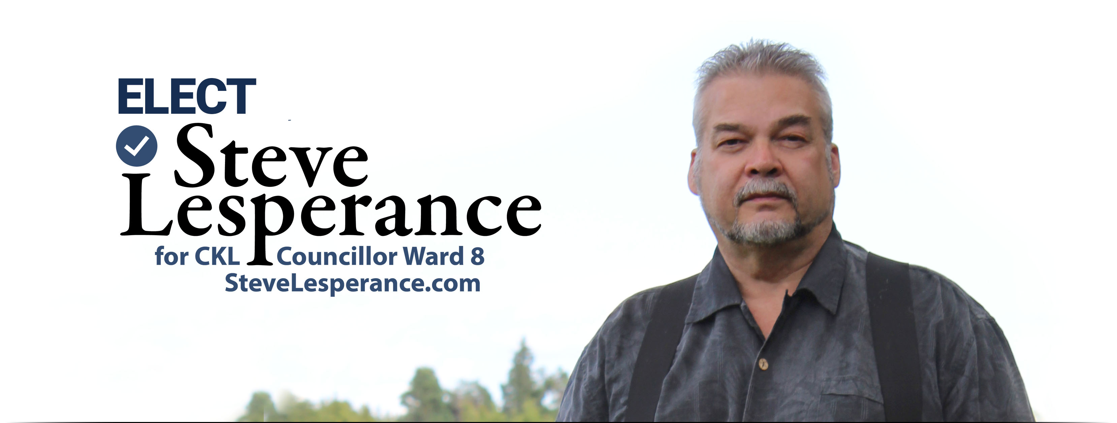

Why I Am Running
I’m running for Councillor to help bring real change to this municipality.
After decades of “same-old, same-old,” even good systems can fall behind.
They must be reviewed, updated and made to work for the people they are meant to serve.
Through my own experiences with City Council, By-law officers and the court system
and by listening to residents facing similar problems,
I have seen how easily people can feel unheard, passed around or left without answers.
It is time to restore a strong voice that works for the people, not against them.
I have a vision and I have already begun building it.
I have created an APP called PITA for tracking public issues!


Got an issue? Put it in PITA…
the Public Issue Tracker APP!
Report it. Map it. Track it. Get answers.
A practical tool for reporting roads, drainage, garbage, by-law, customer-service and other municipal issues.
Each report creates a record that can be followed up, updated and reported back to the resident.
With permission, a general location, category and status can appear on a privacy-protected public map, never a resident’s name, contact information, private notes or exact address.
One complaint can be overlooked. A visible pattern cannot.

My Vision
“Change is coming means a City Hall that remembers it works for the people”
When residents elect representatives with courage, character and common sense,
City Hall can become more responsive, transparent and accountable.
Problems should be confronted, decisions made, responsibility accepted and commitments followed through.
Real leadership does not chase approval or disappear when opposition comes. It stands for truth,
judges fairly, seeks wisdom, accepts correction and serves without favouritism.
It protects the people placed in its care and finishes the work it begins.
That is the leadership I will bring: the courage to begin, the character to continue,
the wisdom to make sound decisions, the humility to serve and the accountability to answer for every action.


About Me
I am a believer and know that I am accountable for my actions.
I will do my best to serve the people of Ward 8.
I come with a history of pushing the envelope in excellence in a variety of fields, including but not limited to:
owner full-service creative media production company, redefining “Legal Aid of Ontario” business process to an RFI/RFP, with skills in Defining Systems Requirements, Specifying Client Requirements, Professional Ethics,
Professional Logistician Executive Certification, development of many start business ups to launch and
would love for you all to see my accomplishments.
Please go to SteveLesperance.com for my resume and other goodies.

My Commitments

1 Lower Taxes  I will fight to lower taxes by cutting waste  and demanding better value for every taxpayer dollar.  2 Basic Services First  Roads, ditches, drainage, snow clearing, garbage,  water and infrastructure must work.  3 Fair By-Laws and Enforcement  I will work for clear, fair by-laws and respectful enforcement applied equally to everyone.  4 Local Jobs and Business  I will support local businesses, attract good jobs, and  keep more of our money working within our community.  5 Protect Taxpayers Through Transparency  City Hall must manage taxpayers’ money responsibly and clearly explain major votes, spending, service results and public decisions. | 6 Protect Rural Life  Farmers, rural residents and property owners  deserve respect and practical policies.  7 Support Seniors and Families  A strong community protects elders,  supports families and the vulnerable.  8 Protect Property Rights and Public Input  Residents should never learn after the fact that zoning affecting their property has changed. I will fight for direct notice, meaningful consultation and a real opportunity for residents to have their say before rezoning decisions are made. I am here to protect the people, defend the use and enjoyment of their property, and ensure City Hall respects the rights, freedoms and principles recognized  in the Canadian Bill of Rights and Constitution.  Decisions must be lawful, transparent, fair and accountable.

ELECT STEVE IF YOU WANT:
Truth Before Spin • Answers Before Excuses • Service Before Politics

ELECT STEVE LESPERANCE
Steve promises accountability by building the system for it.

WARD 8 COUNCILLOR
info@stevelesperance.com | SteveLesperance.com | www.facebook.com/VoteSteveLesperance

